MONTESSORI MAGNET SCHOOL
ALBANY - SCHOOL

School Detail :-
The Montessori Magnet School provides a national model for excellent public Montessori education.The school serves the Greater Hartford community.
The Montessori Magnet School provides a national model for excellent public Montessori education. The school serves the Greater Hartford community, offering a traditional Montessori education for students ages 3-12, extended child care for students participating in the full-day program and a diverse environment in our custom-built school facility.
Students progress academically and socially through an integrated curriculum that combines the Montessori pedagogy with highly effective instructional strategies.

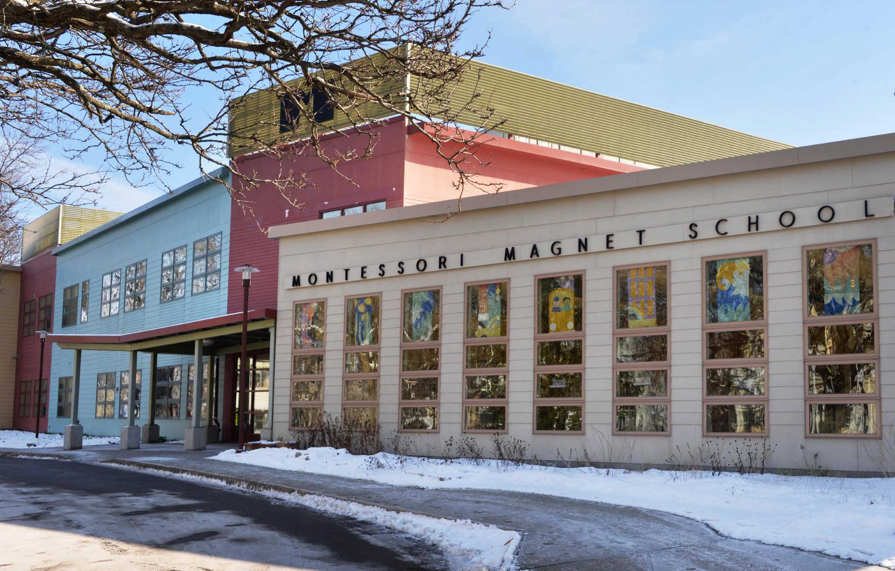

MINIMUM CAPACITY :-
The Minumum intake capacity
of students is between 280-310
children

LIBRARY :-
The Libarary is Available.

CANTEEN:-
The Canteen Facility is Available.

BOARDING :-
No availablility of boarding.

SPORTS :-
There are different categories
sports available.
Girls Volleyball
Boys Volleyball
Football

